**Application IMPACT Methods and Tools Education**

OVERVIEW :-

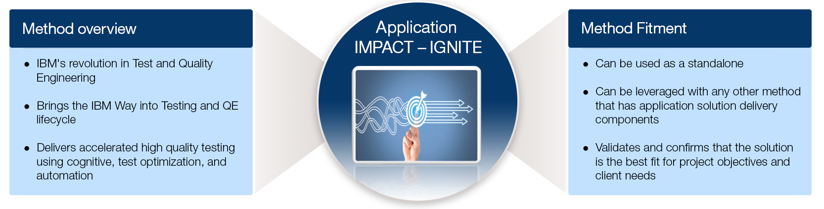

Today’s testing services have to cater to these client needs in a rapidly changing technology and business landscape. – 1. High Quality, 2. Speed-to-market, 3. Respond to changes with agility, 4. Cost-comprtitive

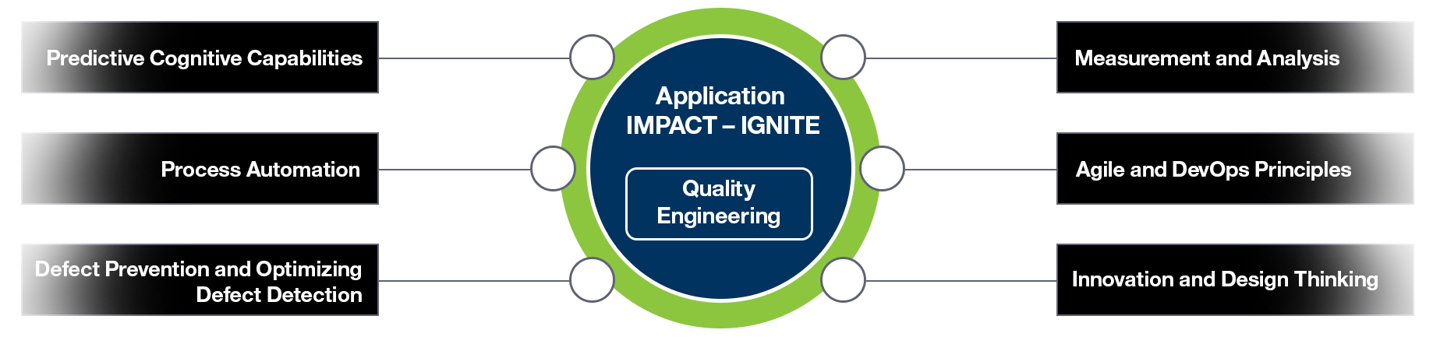

Application IMPACT – IGNITE brings the focus on quality by design into every task and activity performed.  
  
The process, tooling, practices, and skills are all integrated into this method to achieve quality engineering.

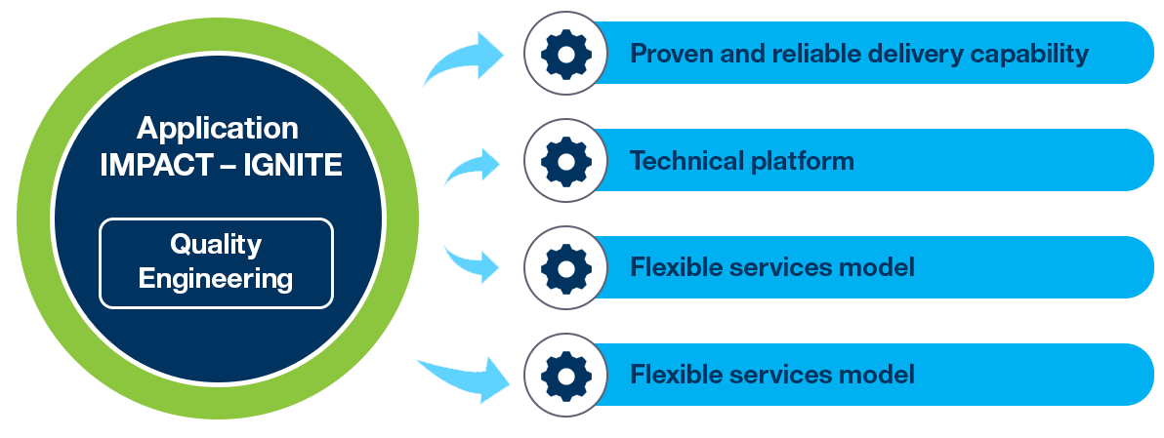

**Overview on  
method artefacts**

The Application IMPACT Method has been refreshed and covers the entire lifecycle of opportunity management, solutioning, and delivery – modernized through process advancements of Design Thinking, Agile, and Cognitive.  
  
Our clients will enjoy seamless and superior experience as all expectations of the entire sales and delivery cycles are met – first time, every time.

Client Vantage Method Portal:

* The Client Vantage Methods Portal will house all of the Methods for easy access, on demand.
* It provide One Stop Access - [Client Vantage Methods Portal.](https://sldcmwas.gps.ihost.com/group/gbs-methods-overview/home-0)

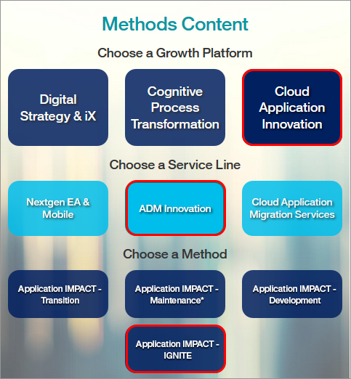

**Best  
practices**

Method Governance:

* The Service Line (SL) lead will own the best practices.
* A method governance team with appropriate representation from all offerings and practices will drive the process for maintaining SL recommended best practices. So, it will add new best practices after appropriate due diligence, and remove others as appropriate.

**Process for submitting and harvesting the best practices :=**

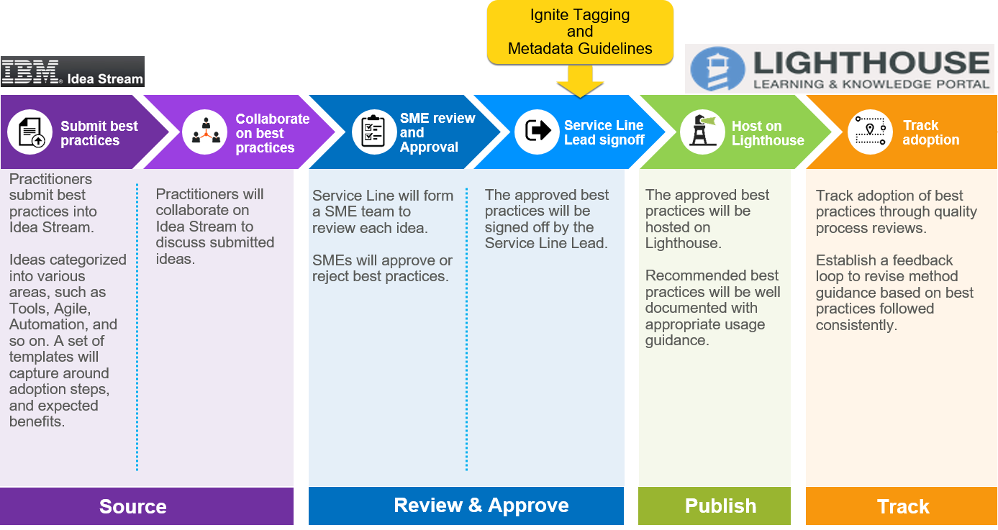

**Delivery  
PM&T profile**

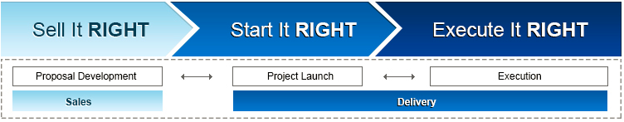

The [PM&T profile application](https://gbspmt.w3ibm.mybluemix.net/PMTProfile) captures the process, and methods and tools (PM&T) usage for GBS engagements during Solutioning and Project Delivery.  
  
**Solutioning:** The PM&T profile must be created once the solution has been completed and prior to proceeding through technical reviews by the Solution Manager to demonstrate adherence to the Service Line standards.  
  
**Delivery:** The PM&T profile must also be completed by the end of Project Launch (or Account Initiation) by the Project Manager (for all SL Consulting Design Build contracts) or the Delivery Project Executive (for AIC ADM Maintenance/Run contracts).

The PM&T profile application is intended for the following GBS audience or the appropriate delegate:

* Solution focused resources (For example: Solution Managers, Opportunity Owners, and Technical Delivery Assessors)
* Project delivery focused resources (For example: Delivery Project Executives and Project Managers)

The data collected using PM&T profile is used to report PM&T compliance and usage information to Service Line and GBS Executive Leadership teams.  
The completion of the PM&T profile is a required part of the [policy for each Service Line](https://w3-connections.ibm.com/wikis/home?lang=en-us#%21/wiki/W46a9e75246f1_4b65_807c_2ddecd8e302a/page/Service%20Line%20Standards).  
  
From the Testing Service Line, as part of Application IMPACT – IGNITE method, the assessment questionnaires are aligned with the method Phases and work practices.